Collaborative Robotics Modeling
FM
CS 2018

Davide Santambrogio
Federico Sandrelli
Andrea Tricarico

Sommario

Dubbi 1
Sommario 2
Domains 4
Predicates (event / state) 4
Variables 5
Axioms 6
Cell 6
Distance((x,y),(w,z), d) 6
Adj((x, y), (w, z)) 6
Layout 7
Walls((x,y)) 7
BlueArea((x,y)) 7
WorkArea((x,y)) 7
BinArea((x,y)) 8
CornerArea((x,y)) 8
LoadArea(x,y) 8
ReleaseArea(x,y) 8
WorkPieces 8
WPposition 8
Robot 8
BasePosition 8
BinPosition 8
Arm 9
Link Cells are Aligned 9
Occupies 9
Link1 and Link2 are Connected 10
ArmBasePosition 10
EEPosition 10
EEFull 10
Arm in Rest Position 11
Link Speed 11
Operator 12
Head Attached to Body 12
Arms Attached to Body 13
HumanArm Cells are Aligned 13
Robot-Layout Interaction 14
Robot Body Always in Blue Area 14
Base Speed 14
Wall’s constraint 15
Mode(mobile) 15
Mode(manipulator) 16
Base-Operator Interaction 16
Base Close to Operator 16
KeepDistance 16
DontMoveWhenAdj 16
SlowInWorkStation 17
Robot Workflow 17
The robot works always 17
Working in Manipulator Mode 17
Operation Timing 17
Working(pickWp/putWP) 17
Ending PickWP/PutWP 18
Working Procedure 18
External Signals 18
Signal 18

Domains
cellDomain: {(x, y) | x >= 0, y >= 0}
robotDomain: {base}
linkDomain: {link1, link2}
binDomain: {bin1, bin2, bin3}
binStateDomain: {full, empty}
humanDomain: { humanHead, humanBody, humanArm1, humanArm2}
operationType: {pickWP, placeWP}
stateType: {manipulator, mobile}
speedValue: {still, veryLow, low, high}

Predicates (event / state)
Distance(cellDomain,cellDomain,integer)
BlueArea(cellDomain)
BinArea(cellDomain)
WorkArea(cellDomain)
CornerArea(cellDomain)
LoadArea(cellDomain)
ReleaseArea(cellDomain)

BasePosition(cellDomain)
LinkPosition( armDomain, cellDomain, cellDomain, cellDomain)
BaseSpeed(speedValue)
LinkSpeed(linkDomain, speedValue)
Working(operationType)
Occupies(armDomain)
Mode(stateType)
BinFull
BinEmpty

HumanBodyPosition(cellDomain)
HumanHeadPosition(cellDomain)
HumanArmPosition(cellDomain, cellDomain, cellDomain)

Signal
AddedWP
RemovedWP

Variables
celli: cellDomain;
link: linkDomain;
operation: operationType;
state: stateType;
integer

Axioms

Cell

Distance((x,y),(w,z), d)
This predicate checks whether the two cells, of which the coordinates are specified, are [d] cells apart from each other (i.e. there are [d-1] cells between them). This distance measure is an approximation that measures distance with a square perimeter. We have chosen to calculate distance this way because it fits well with the how movements have been modelled.

Note that “Distance(cell1, cell2, 0)” means that cell1 and cell2 are the same cell.

Adj((x, y), (w, z))
This predicate assures that the two cells (specified by position) are next to each other (diagonally included).

IMPORTANT NOTE ON CELLS

Throughout this project we will refer to a generic cell using the variable “” (where i is a number).
So, for example:

means that if the position of the base is detected on (generic cell), then must be one of the cells in the blue area.

Layout

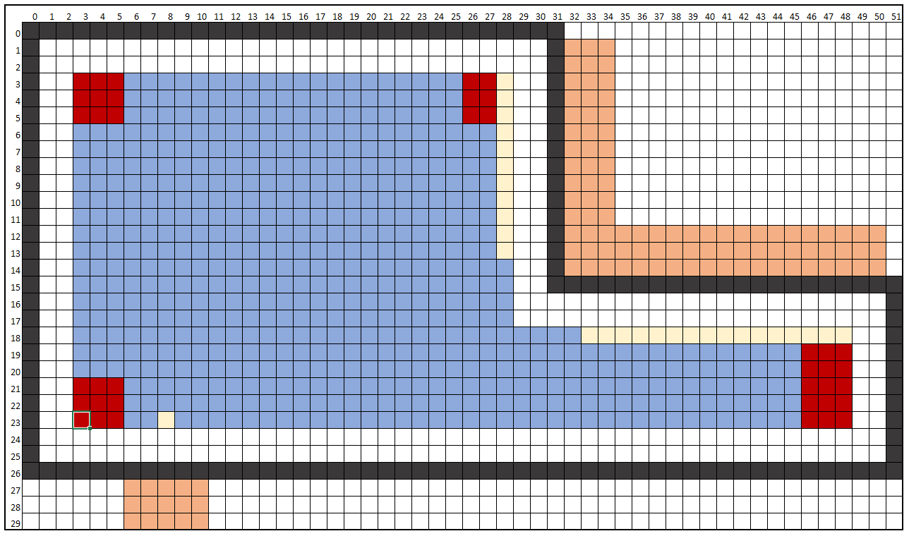

Walls((x,y))
This predicates delimits the area of the walls, that are the limits for the robot’s base.

BlueArea((x,y))
This predicates delimits the area of the blue cells. It is specific to our scenario.
The delimitation can be seen clearly in the Layout image.

WorkArea((x,y))

BinArea((x,y))

CornerArea((x,y))

LoadArea(x,y)

ReleaseArea(x,y)

WorkPieces
WorkPieces (WPs) are modelled as single cell entities with no particular constraints.

WPposition

This predicate implies nothing and is only useful for future constraints.

Robot

BasePosition
This predicate assures that the robot always has a position and this is identified by a unique cell (it represents the central cell of the robot’s base).

BinPosition
We have decided to model the bin as a single cell on the robot’s body. It is located on the side opposite to the arm base (the arm base is the first cell of link1). The motion of the arm base simulates rotation of the robot, so the bin will obviously rotate with it, remaining on the opposite side of the arm base as it moves around the robot base’s center.

Arm

Link Cells are Aligned
Here we ensure that the cells describing the position if the Robot Arm Links are in a straight row (i.e. the link does not bend).
What this is saying (just like for “humanArm”):
are the coordinates of the three cells occupied by the link.
Given the position of the first cell and the second cell, the third cell must “continue” in the same direction. It is important to to note that the cells can overlap. This is because we are taking into account the fact that the link can be inclined upwards. Seen from above, this will result in the link occupying 2 or 1 cell in total. Note that link3 has not been modelled directly but it’s effect is implicit in how we modelled the inclination of the arm.

Occupies
This predicate is true when the arm of the robot (composed of link1 and link2) occupies the specified cell.

What this is saying:
is “occupied” by the arm if at least one of the cells of one of the LinkPositions is .

Link1 and Link2 are Connected
The two links are always correctly concatenated. This means that the last cell of the first link is always the same first cell of the second link.
What this is saying:
Note that both the first cell of link1 and the third cell of link2 are declared as cell1: they are the same cell.

ArmBasePosition
The base of the arm is the first cell of link1. It represents the point of attachment between robot and arm. Here is where we have rotation both on the horizontal and on the vertical axis.
To model the rotation of the robot, the arm base can change position around the robot’s BasePosition.

EEPosition
Since the end effector doesn’t add length to the arm, we decided not to model it explicitly but simply to consider the last cell of the arm as the end effector.

EEFull
When the end effector is full, it is carrying a workpiece (WP).
Ps: it can only carry one WP at a time.

What this is saying:
If the end effector is full, then it should be carrying a WP (only one!). We did not use double implication because the EE could be just hovering above the WP without having picked it up.

Arm in Rest Position
At any instant the robot can be operating in only one of the following two states: Mobile; Manipulator.
When it is moving around (i.e. it is operating in the Mobile state), the arm should not protrude from the robot’s body and it should not be moving.

What this is saying:
None of the cells occupied by the links are at a distance greater than 2 from the robot central cell.

Link Speed
Here we define the speed of arm links. Given the nature of a link (straight long object, rotating with center of rotation on one of the extremities) we know that the third cell (link composed of three cells, rotation base on the first) will be the fastest. Therefore we will consider only the third cell for speed limitation; the other two will be slower anyway.

;

Operator

Head Attached to Body
Here we are making sure that if a head is detected, then it is attached to the relative body.

Arms Attached to Body
Here we are making sure that if an is detected, then it is attached to the relative body.

HumanArm Cells are Aligned
Here we ensure that the cells describing the position if the Operator Arm are in a straight row (i.e. the arm does not bend). We have considered this approximation to be acceptable.
What this is saying:
are the coordinates of the three cells occupied by the arm.
Given the position of the first cell and the second cell, the third cell must “continue” in the same direction. It is important to to note that the arm can “shrink” in lenghth. This is because we are taking into account the fact that the arm can be inclined. Seen from above, this will result in the arm occupying 2 or 1 cell in total.

Approximation note:
The link is modeled as a row of three cells that can also be diagonally aligned. We realize that the diagonal length is longer than the vertical or horizontal length, but we have decided to accept this approximation of the model.

Robot-Layout Interaction

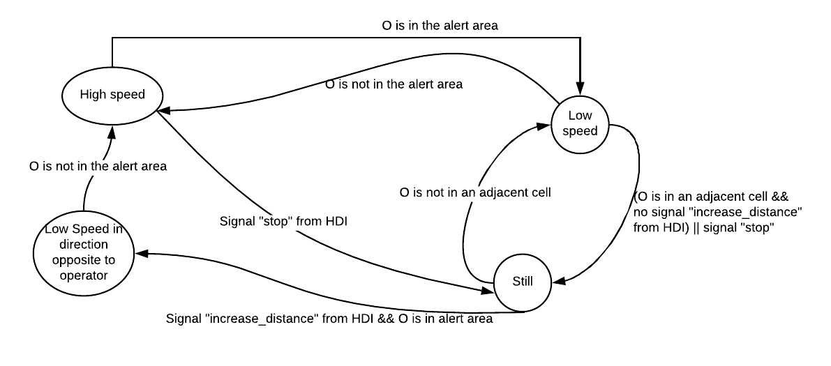

Robot Body Always in Blue Area

Base Speed
These three predicates model the movement of the robot. They differentiate between three different speeds checking that the robots movement are coherent with the speed it should be moving at.

These predicates model the change of speed in the robot’s movements, the possible changes are:

Wall’s constraint
The position of the robot’s base has to fulfil the physical constraints given by the walls.

Mode(mobile)
This predicate tells us that, when located in the blue area outside of the LoadArea or the ReleaseArea, it should be operating in “mobile” stateType. This means that only the robot’s body is functioning (to move around), while the arm is in the rest position to improve safeness of movements.

Mode(manipulator)
At any instant the robot can be operating in only one of the following two states: Mobile, Manipulator. When it is in the manipulator mode, the robot’s base should be still and the arm should be operating on a task (picking up or putting down the WPs).

Base-Operator Interaction

Base Close to Operator
Distance(base, operator, d)

KeepDistance
se un operatore e’ vicino, il robot non puo’ avvicinarsi (puo’ solo allontanarsi) (tipo “if operator has not moved and I moved, then distance has increased”)

DontMoveWhenAdj
se il robot e’ affianco all’operatore allora e’ “still”

SlowInWorkStation
Se il robot e’ nell’area workstation o bin area allora la velocita’ non e’ ne’ media ne’ veloce

Robot Workflow

The robot works always
At every instant, in absence of signals, the robot is working or it is moving between the LoadArea and the ReleaseArea to perform the next operation.

If the robot is in mobile mode and there are WPs in its bin, then, in the future, it will reach the RealeaseArea in order to empty his local bin.

Working in Manipulator Mode

Operation Timing
At every instant, after beginning a certain operation (either pickWP or putWP), the robot will continue performing the same operation or will change its mode from manipulator to mobile but only in a discrete way

Working(pickWp/putWP)
The “Working(operation)” predicates states that the Robot remained still in the correct Area (without having BinFull or Signal events) since reached the correct position itself for that specific operation (the LoadArea for pickWP and the ReleaseArea for putWP)

Ending PickWP/PutWP
The Robot will continue picking up/putting down WPs until the bin becomes full/empty (or a special signal force it), then it will move its arm in the rest postìition

Working Procedure
Every time the robot adds/removes a WP into/from the bin and it has not finish the entire operation (so the bin it is not already Full/Empty) it continues the operation

External Signals

Mettere i segnali del tipo: “pick up WP”. in questo caso la condizione sarebbe notEEfull e che l’EEPosition sia la stessa del WP.
lo stato empty/full puo’ cambiare solo in certi istanti:
empty->full solo se sono sopra un WP
full->empty solo sopra il local bin

Il cambio di stato da operator a mobile deve assicurarsi che il braccio sia nella rest

Si potrebbe fare un po’ come una rete di petri dove i token sono i segnali:
Tipo per iniziare a muoversi aspetta vari segnali tipo bin full, arm in rest position, safeto move

Signal
This is the generic signal. It allows to stop the robot in doing its routine in order to manage the issue recognized by the signal.

POSITION OF R ARM
POSITION OF R CART:
POSITION OF O HEAD
POSITION OF O ARM
POSITION OF O BODY

